**Homework 5**

Remember that your programs must read the data from the text files exactly as they appear. You may not edit the text files to make them more convenient for SAS. Turn in the code, log file and output. If any of these 3 items is missing then you will not be graded for that question. Use the snipping tool instead of screen shots and make sure the font is large enough for me to read.

1. Refer to CATS datasets. Write a SAS program that reads in three separate SAS datasets from CATS1, CATS2, and CATS3 data. Make two new variables which represent the GFR at week 0 for the treated kidney and the GFR at week 0 for the untreated kidney. Print only the cats’ names and the two new variables, identified as “treated” or “untreated” (not “left or “right”).

The output looks like this:

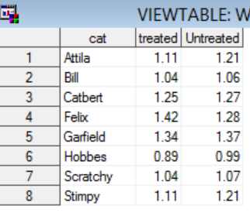

Code:

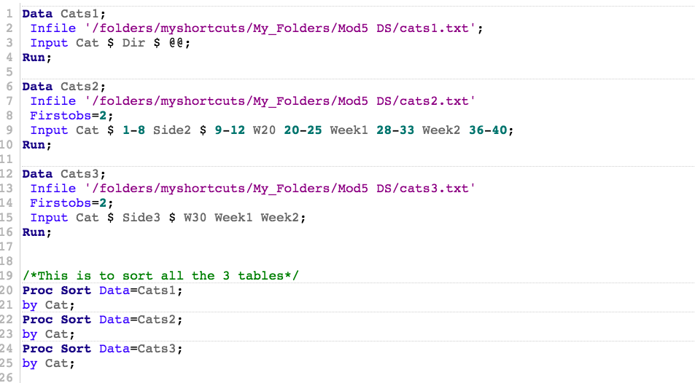

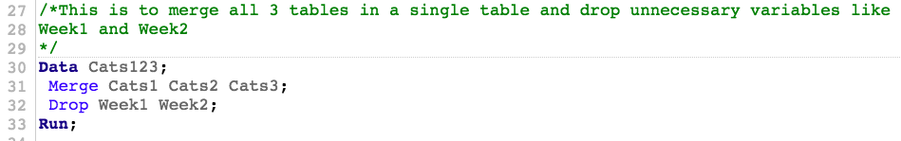

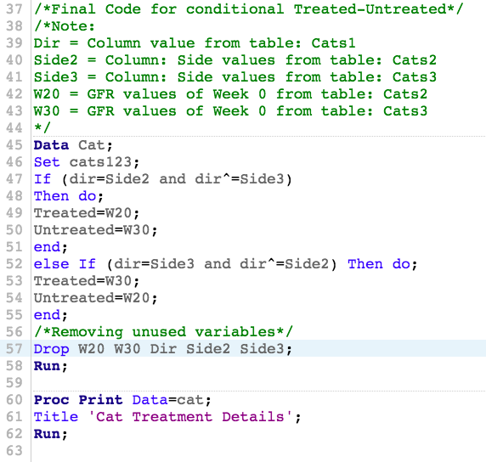

Log:

|  |
| --- |
| 1 OPTIONS NONOTES NOSTIMER NOSOURCE NOSYNTAXCHECK;  72  73 *Ques 1;  74  75 Data Cats1;  76 Infile '/folders/myshortcuts/My_Folders/Mod5 DS/cats1.txt';  77 Input Cat $ Dir $ @@;  78 Run;    NOTE: The infile '/folders/myshortcuts/My_Folders/Mod5 DS/cats1.txt' is:  Filename=/folders/myshortcuts/My_Folders/Mod5 DS/cats1.txt,  Owner Name=root,Group Name=vboxsf,  Access Permission=-rwxrwx---,  Last Modified=20Mar2018:08:31:43,  File Size (bytes)=132    NOTE: 2 records were read from the infile '/folders/myshortcuts/My_Folders/Mod5 DS/cats1.txt'.  The minimum record length was 64.  The maximum record length was 64.  NOTE: SAS went to a new line when INPUT statement reached past the end of a line.  NOTE: The data set WORK.CATS1 has 8 observations and 2 variables.  NOTE: DATA statement used (Total process time):  real time 0.01 seconds  cpu time 0.00 seconds      79  80 Data Cats2;  81 Infile '/folders/myshortcuts/My_Folders/Mod5 DS/cats2.txt'  82 Firstobs=2;  83 Input Cat $ 1-8 Side2 $ 9-12 W20 20-25 Week1 28-33 Week2 36-40;  84 Run;    NOTE: The infile '/folders/myshortcuts/My_Folders/Mod5 DS/cats2.txt' is:  Filename=/folders/myshortcuts/My_Folders/Mod5 DS/cats2.txt,  Owner Name=root,Group Name=vboxsf,  Access Permission=-rwxrwx---,  Last Modified=20Mar2018:08:31:47,  File Size (bytes)=380    NOTE: 8 records were read from the infile '/folders/myshortcuts/My_Folders/Mod5 DS/cats2.txt'.  The minimum record length was 40.  The maximum record length was 40.  NOTE: The data set WORK.CATS2 has 8 observations and 5 variables.  NOTE: DATA statement used (Total process time):  real time 0.01 seconds  cpu time 0.02 seconds      85  86 Data Cats3;  87 Infile '/folders/myshortcuts/My_Folders/Mod5 DS/cats3.txt'  88 Firstobs=2;  89 Input Cat $ Side3 $ W30 Week1 Week2;  90 Run;    NOTE: The infile '/folders/myshortcuts/My_Folders/Mod5 DS/cats3.txt' is:  Filename=/folders/myshortcuts/My_Folders/Mod5 DS/cats3.txt,  Owner Name=root,Group Name=vboxsf,  Access Permission=-rwxrwx---,  Last Modified=20Mar2018:08:31:51,  File Size (bytes)=394    NOTE: 8 records were read from the infile '/folders/myshortcuts/My_Folders/Mod5 DS/cats3.txt'.  The minimum record length was 41.  The maximum record length was 43.  NOTE: The data set WORK.CATS3 has 8 observations and 5 variables.  NOTE: DATA statement used (Total process time):  real time 0.01 seconds  cpu time 0.00 seconds      91  92  93 /*This is to sort all the 3 tables*/  94 Proc Sort Data=Cats1;  95 by Cat;    NOTE: There were 8 observations read from the data set WORK.CATS1.  NOTE: The data set WORK.CATS1 has 8 observations and 2 variables.  NOTE: PROCEDURE SORT used (Total process time):  real time 0.00 seconds  cpu time 0.01 seconds    96 Proc Sort Data=Cats2;    97 by Cat;    NOTE: There were 8 observations read from the data set WORK.CATS2.  NOTE: The data set WORK.CATS2 has 8 observations and 5 variables.  NOTE: PROCEDURE SORT used (Total process time):  real time 0.00 seconds  cpu time 0.00 seconds    98 Proc Sort Data=Cats3;    99 by Cat;  100  101 /*This is to merge all 3 tables in a single table and drop unnecessary variables like  102 Week1 and Week2  103 */    NOTE: There were 8 observations read from the data set WORK.CATS3.  NOTE: The data set WORK.CATS3 has 8 observations and 5 variables.  NOTE: PROCEDURE SORT used (Total process time):  real time 0.00 seconds  cpu time 0.01 seconds    104 Data Cats123;    105 Merge Cats1 Cats2 Cats3;  106 Drop Week1 Week2;  107 Run;    NOTE: There were 8 observations read from the data set WORK.CATS1.  NOTE: There were 8 observations read from the data set WORK.CATS2.  NOTE: There were 8 observations read from the data set WORK.CATS3.  NOTE: The data set WORK.CATS123 has 8 observations and 6 variables.  NOTE: DATA statement used (Total process time):  real time 0.00 seconds  cpu time 0.00 seconds      108  109 /*Final Code for conditional Treated-Untreated*/  110 /*Note:  111 Dir = Column value from table: Cats1  112 Side2 = Column: Side values from table: Cats2  113 Side3 = Column: Side values from table: Cats3  114 W20 = GFR values of Week 0 from table: Cats2  115 W30 = GFR values of Week 0 from table: Cats3  116 */  117 Data Cat;  118 Set cats123;  119 If (dir=Side2 and dir^=Side3)  120 Then do;  121 Treated=W20;  122 Untreated=W30;  123 end;  124 else If (dir=Side3 and dir^=Side2) Then do;  125 Treated=W30;  126 Untreated=W20;  127 end;  128 /*Removing unused variables*/  129 Drop W20 W30 Dir Side2 Side3;  130 Run;    NOTE: There were 8 observations read from the data set WORK.CATS123.  NOTE: The data set WORK.CAT has 8 observations and 3 variables.  NOTE: DATA statement used (Total process time):  real time 0.00 seconds  cpu time 0.01 seconds      131  132 Proc Print Data=cat;  133 Title 'Cat Treatment Details';  134 Run;    NOTE: There were 8 observations read from the data set WORK.CAT.  NOTE: PROCEDURE PRINT used (Total process time):  real time 0.05 seconds  cpu time 0.05 seconds      135  136  137 OPTIONS NONOTES NOSTIMER NOSOURCE NOSYNTAXCHECK;  150 |

Results:

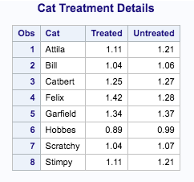

1. Refer to SOCCER dataset. Suppose that the team plans to go to Europe for some exhibition matches, and you need to send their hosts some information about the players. Use a SAS program to convert the players’ heights to meters, then print the players’ first and last names, jersey numbers, and heights in meters. For this question, list only 3 significant digits for the heights (example: 5 feet, 8 inches is equivalent to 1.73 meters).

Code:

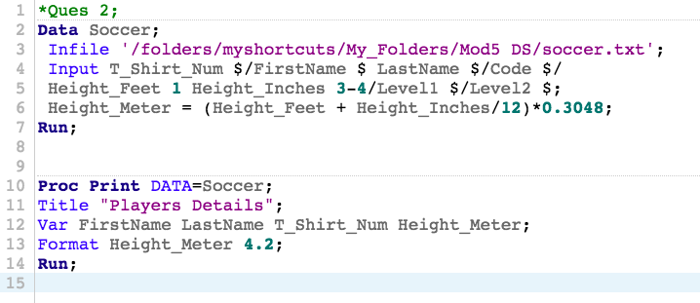

Log:

|  |
| --- |
| 1 OPTIONS NONOTES NOSTIMER NOSOURCE NOSYNTAXCHECK;  72  73 *Ques 2;  74 Data Soccer;  75 Infile '/folders/myshortcuts/My_Folders/Mod5 DS/soccer.txt';  76 Input T_Shirt_Num $/FirstName $ LastName $/Code $/  77 Height_Feet 1 Height_Inches 3-4/Level1 $/Level2 $;  78 Height_Meter = (Height_Feet + Height_Inches/12)*0.3048;  79 Run;    NOTE: The infile '/folders/myshortcuts/My_Folders/Mod5 DS/soccer.txt' is:  Filename=/folders/myshortcuts/My_Folders/Mod5 DS/soccer.txt,  Owner Name=root,Group Name=vboxsf,  Access Permission=-rwxrwx---,  Last Modified=20Mar2018:08:31:59,  File Size (bytes)=4608    NOTE: 192 records were read from the infile '/folders/myshortcuts/My_Folders/Mod5 DS/soccer.txt'.  The minimum record length was 22.  The maximum record length was 22.  NOTE: The data set WORK.SOCCER has 32 observations and 9 variables.  NOTE: DATA statement used (Total process time):  real time 0.00 seconds  cpu time 0.01 seconds      80  81  82 Proc Print DATA=Soccer;  83 Title "Players Details";  84 Var FirstName LastName T_Shirt_Num Height_Meter;  85 Format Height_Meter 4.2;  86 Run;    NOTE: There were 32 observations read from the data set WORK.SOCCER.  NOTE: PROCEDURE PRINT used (Total process time):  real time 0.12 seconds  cpu time 0.12 seconds      87  88  89 OPTIONS NONOTES NOSTIMER NOSOURCE NOSYNTAXCHECK;  102 |

Results:

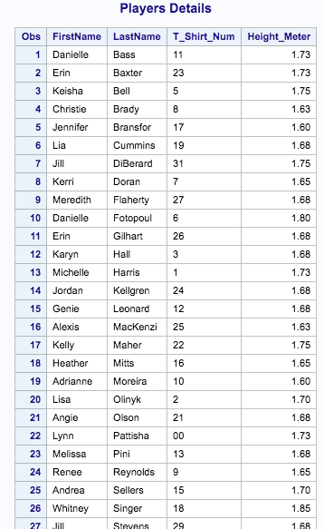

1. There is a mistake in the HOCKEY dataset. The Buckeyes (OSU) lost to Boston College by a score of 5-2 (Boston College scored 5) in their last game. Write a SAS program which reads the data from your USB and corrects the error with programming statements. Read the month, day, and year as three separate numeric variables, and create a new variable for the date by using MDY command. Print the revised dataset and use an appropriate format for the date.

Code:

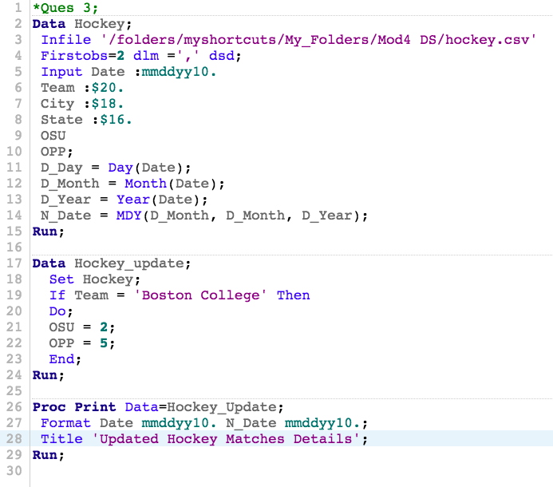

Log:

|  |
| --- |
| 1 OPTIONS NONOTES NOSTIMER NOSOURCE NOSYNTAXCHECK;  72  73 *Ques 3;  74 Data Hockey;  75 Infile '/folders/myshortcuts/My_Folders/Mod4 DS/hockey.csv'  76 Firstobs=2 dlm =',' dsd;  77 Input Date :mmddyy10.  78 Team :$20.  79 City :$18.  80 State :$16.  81 OSU  82 OPP;  83 D_Day = Day(Date);  84 D_Month = Month(Date);  85 D_Year = Year(Date);  86 N_Date = MDY(D_Month, D_Month, D_Year);  87 Run;    NOTE: The infile '/folders/myshortcuts/My_Folders/Mod4 DS/hockey.csv' is:  Filename=/folders/myshortcuts/My_Folders/Mod4 DS/hockey.csv,  Owner Name=root,Group Name=vboxsf,  Access Permission=-rwxrwx---,  Last Modified=01Mar2018:22:26:10,  File Size (bytes)=1701    NOTE: 36 records were read from the infile '/folders/myshortcuts/My_Folders/Mod4 DS/hockey.csv'.  The minimum record length was 35.  The maximum record length was 56.  NOTE: The data set WORK.HOCKEY has 36 observations and 10 variables.  NOTE: DATA statement used (Total process time):  real time 0.01 seconds  cpu time 0.02 seconds      88  89 Data Hockey_update;  90 Set Hockey;  91 If Team = 'Boston College' Then  92 Do;  93 OSU = 2;  94 OPP = 5;  95 End;  96 Run;    NOTE: There were 36 observations read from the data set WORK.HOCKEY.  NOTE: The data set WORK.HOCKEY_UPDATE has 36 observations and 10 variables.  NOTE: DATA statement used (Total process time):  real time 0.02 seconds  cpu time 0.01 seconds      97  98 Proc Print Data=Hockey_Update;  99 Format Date mmddyy10. N_Date mmddyy10.;  100 Title 'Updated Hockey Matches Details';  101 Run;    NOTE: There were 36 observations read from the data set WORK.HOCKEY_UPDATE.  NOTE: PROCEDURE PRINT used (Total process time):  real time 0.18 seconds  cpu time 0.18 seconds      102  103  104 OPTIONS NONOTES NOSTIMER NOSOURCE NOSYNTAXCHECK;  117 |

Results:

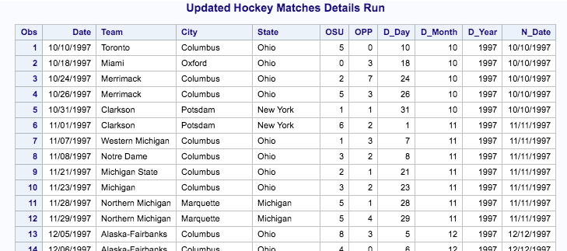

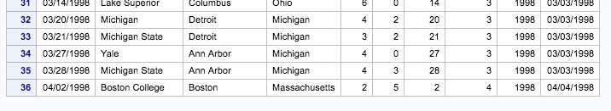

1. Refer to the USEDCARS data. Write a SAS program which reads the full dataset. Then create a dataset which contains only the least expensive car offered by each dealer. Print the new dataset, showing the year, manufacturer, model, price, and name of the dealer. This dataset should have 15 observations, and each dealer should appear exactly once.

Code:

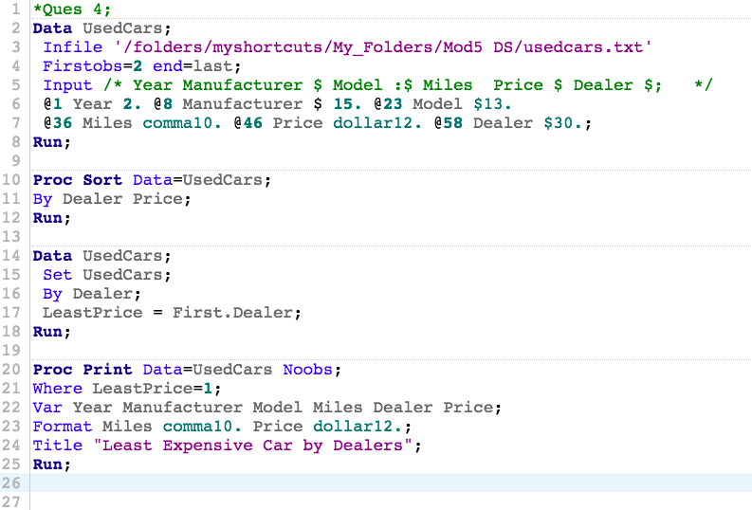

Log:

|  |
| --- |
| 1 OPTIONS NONOTES NOSTIMER NOSOURCE NOSYNTAXCHECK;  72  73 *Ques 4;  74 Data UsedCars;  75 Infile '/folders/myshortcuts/My_Folders/Mod5 DS/usedcars.txt'  76 Firstobs=2 end=last;  77 Input /* Year Manufacturer $ Model :$ Miles Price $ Dealer $; */  78 @1 Year 2. @8 Manufacturer $ 15. @23 Model $13.  79 @36 Miles comma10. @46 Price dollar12. @58 Dealer $30.;  80 Run;    NOTE: The infile '/folders/myshortcuts/My_Folders/Mod5 DS/usedcars.txt' is:  Filename=/folders/myshortcuts/My_Folders/Mod5 DS/usedcars.txt,  Owner Name=root,Group Name=vboxsf,  Access Permission=-rwxrwx---,  Last Modified=20Mar2018:08:32:07,  File Size (bytes)=4743    NOTE: Invalid data for Year in line 52 1-2.  NOTE: Invalid data for Miles in line 52 36-45.  NOTE: LOST CARD.  NOTE: Invalid data errors for file ''/folders/myshortcuts/My_Folders/Mod5 DS/usedcars.txt'' occurred outside the printed range.  NOTE: Increase available buffer lines with the INFILE n= option.  last=1 Year=. Manufacturer=Gainesville Su Model=n Classified Miles=. Price=. Dealer= _ERROR_=1 _N_=51  NOTE: 51 records were read from the infile '/folders/myshortcuts/My_Folders/Mod5 DS/usedcars.txt'.  The minimum record length was 51.  The maximum record length was 91.  NOTE: SAS went to a new line when INPUT statement reached past the end of a line.  NOTE: The data set WORK.USEDCARS has 50 observations and 6 variables.  NOTE: DATA statement used (Total process time):  real time 0.01 seconds  cpu time 0.01 seconds      81  82 Proc Sort Data=UsedCars;  83 By Dealer Price;  84 Run;    NOTE: There were 50 observations read from the data set WORK.USEDCARS.  NOTE: The data set WORK.USEDCARS has 50 observations and 6 variables.  NOTE: PROCEDURE SORT used (Total process time):  real time 0.02 seconds  cpu time 0.01 seconds      85  86 Data UsedCars;  87 Set UsedCars;  88 By Dealer;  89 LeastPrice = First.Dealer;  90 Run;    NOTE: There were 50 observations read from the data set WORK.USEDCARS.  NOTE: The data set WORK.USEDCARS has 50 observations and 7 variables.  NOTE: DATA statement used (Total process time):  real time 0.00 seconds  cpu time 0.01 seconds      91  92 Proc Print Data=UsedCars Noobs;  93 Where LeastPrice=1;  94 Var Year Manufacturer Model Miles Dealer Price;  95 Format Miles comma10. Price dollar12.;  96 Title "Least Expensive Car by Dealers";  97 Run;    NOTE: There were 15 observations read from the data set WORK.USEDCARS.  WHERE LeastPrice=1;  NOTE: PROCEDURE PRINT used (Total process time):  real time 0.10 seconds  cpu time 0.11 seconds      98  99  100  101  102 OPTIONS NONOTES NOSTIMER NOSOURCE NOSYNTAXCHECK;  115 |

Results:

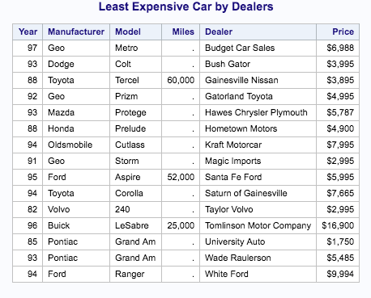

1. Refer to the BREAD dataset. Suppose that you need to create a reference list of bread recipes that do not use eggs (for dietary requirements or preferences, or perhaps you forgot to buy eggs). Create and print a permanent SAS dataset, using LIBNAME and associated commands, which contains only the recipes which use no eggs.

Code:

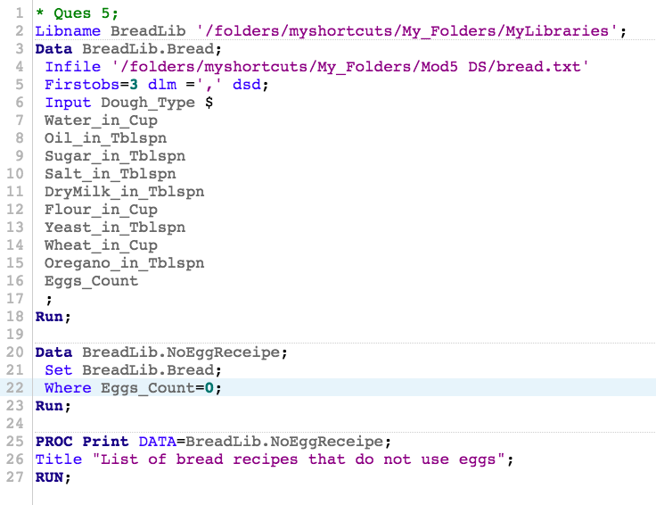

Log:

|  |
| --- |
| 1 OPTIONS NONOTES NOSTIMER NOSOURCE NOSYNTAXCHECK;  72  73 * Ques 5;  74 Libname BreadLib '/folders/myshortcuts/My_Folders/MyLibraries';  NOTE: Libref BREADLIB was successfully assigned as follows:  Engine: V9  Physical Name: /folders/myshortcuts/My_Folders/MyLibraries  75 Data BreadLib.Bread;  76 Infile '/folders/myshortcuts/My_Folders/Mod5 DS/bread.txt'  77 Firstobs=3 dlm =',' dsd;  78 Input Dough_Type $  79 Water_in_Cup  80 Oil_in_Tblspn  81 Sugar_in_Tblspn  82 Salt_in_Tblspn  83 DryMilk_in_Tblspn  84 Flour_in_Cup  85 Yeast_in_Tblspn  86 Wheat_in_Cup  87 Oregano_in_Tblspn  88 Eggs_Count  89 ;  90 Run;    NOTE: The infile '/folders/myshortcuts/My_Folders/Mod5 DS/bread.txt' is:  Filename=/folders/myshortcuts/My_Folders/Mod5 DS/bread.txt,  Owner Name=root,Group Name=vboxsf,  Access Permission=-rwxrwx---,  Last Modified=20Mar2018:08:31:16,  File Size (bytes)=527    NOTE: 11 records were read from the infile '/folders/myshortcuts/My_Folders/Mod5 DS/bread.txt'.  The minimum record length was 30.  The maximum record length was 38.  NOTE: The data set BREADLIB.BREAD has 11 observations and 11 variables.  NOTE: DATA statement used (Total process time):  real time 0.03 seconds  cpu time 0.02 seconds      91  92 Data BreadLib.NoEggReceipe;  93 Set BreadLib.Bread;  94 Where Eggs_Count=0;  95 Run;    NOTE: There were 8 observations read from the data set BREADLIB.BREAD.  WHERE Eggs_Count=0;  NOTE: The data set BREADLIB.NOEGGRECEIPE has 8 observations and 11 variables.  NOTE: DATA statement used (Total process time):  real time 0.03 seconds  cpu time 0.02 seconds      96  97 PROC Print DATA=BreadLib.NoEggReceipe;  98 Title "List of bread recipes that do not use eggs";  99 RUN;    NOTE: There were 8 observations read from the data set BREADLIB.NOEGGRECEIPE.  NOTE: PROCEDURE PRINT used (Total process time):  real time 0.10 seconds  cpu time 0.09 seconds      100  101 OPTIONS NONOTES NOSTIMER NOSOURCE NOSYNTAXCHECK;  114 |

Results:

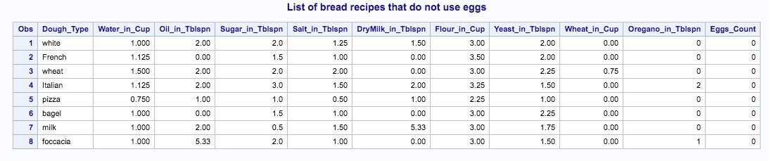

1. Refer to the CLINTON dataset. Gallup has conducted more polls to assess President Clinton’s job approval rating since the CLINTON dataset was created. The data are shown below:

Date Approve Disapprove No opinion

8-18-98 66 29 5

8-20-98 61 34 5

8-21-98 62 35 3

9-1-98 62 33 5

9-10-98 60 37 3

9-11-98 63 34 3

Create two datasets in SAS. One dataset should consist of the numbers in the file CLINTON.TXT and the second dataset should contain the numbers listed above. Combine the two datasets into a larger dataset with the appropriate commands, sort the observations in that dataset in descending order by date (so that September 11, 1998 appears first), and print the larger dataset. Use an appropriate format to print the date variable.

Code:

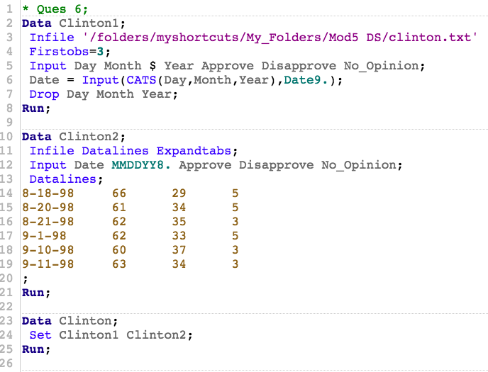

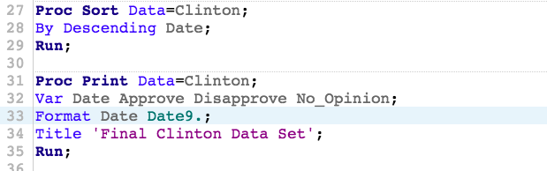

Log:

|  |
| --- |
| 1 OPTIONS NONOTES NOSTIMER NOSOURCE NOSYNTAXCHECK;  72  73 * Ques 6;  74 Data Clinton1;  75 Infile '/folders/myshortcuts/My_Folders/Mod5 DS/clinton.txt'  76 Firstobs=3;  77 Input Day Month $ Year Approve Disapprove No_Opinion;  78 Date = Input(CATS(Day,Month,Year),Date9.);  79 Drop Day Month Year;  80 Run;    NOTE: The infile '/folders/myshortcuts/My_Folders/Mod5 DS/clinton.txt' is:  Filename=/folders/myshortcuts/My_Folders/Mod5 DS/clinton.txt,  Owner Name=root,Group Name=vboxsf,  Access Permission=-rwxrwx---,  Last Modified=20Mar2018:08:31:54,  File Size (bytes)=6120    NOTE: 140 records were read from the infile '/folders/myshortcuts/My_Folders/Mod5 DS/clinton.txt'.  The minimum record length was 41.  The maximum record length was 41.  NOTE: The data set WORK.CLINTON1 has 140 observations and 4 variables.  NOTE: DATA statement used (Total process time):  real time 0.00 seconds  cpu time 0.01 seconds      81  82 Data Clinton2;  83 Infile Datalines Expandtabs;  84 Input Date MMDDYY8. Approve Disapprove No_Opinion;  85 Datalines;    NOTE: The data set WORK.CLINTON2 has 6 observations and 4 variables.  NOTE: DATA statement used (Total process time):  real time 0.00 seconds  cpu time 0.00 seconds    92 ;    93 Run;  94  95 Data Clinton;  96 Set Clinton1 Clinton2;  97 Run;    NOTE: There were 140 observations read from the data set WORK.CLINTON1.  NOTE: There were 6 observations read from the data set WORK.CLINTON2.  NOTE: The data set WORK.CLINTON has 146 observations and 4 variables.  NOTE: DATA statement used (Total process time):  real time 0.00 seconds  cpu time 0.00 seconds      98  99 Proc Sort Data=Clinton;  100 By Descending Date;  101 Run;    NOTE: There were 146 observations read from the data set WORK.CLINTON.  NOTE: The data set WORK.CLINTON has 146 observations and 4 variables.  NOTE: PROCEDURE SORT used (Total process time):  real time 0.00 seconds  cpu time 0.00 seconds      102  103 Proc Print Data=Clinton;  104 Var Date Approve Disapprove No_Opinion;  105 Format Date Date9.;  106 Title 'Final Clinton Data Set';  107 Run;    NOTE: There were 146 observations read from the data set WORK.CLINTON.  NOTE: PROCEDURE PRINT used (Total process time):  real time 0.24 seconds  cpu time 0.25 seconds      108  109  110 OPTIONS NONOTES NOSTIMER NOSOURCE NOSYNTAXCHECK;  123 |

Results:

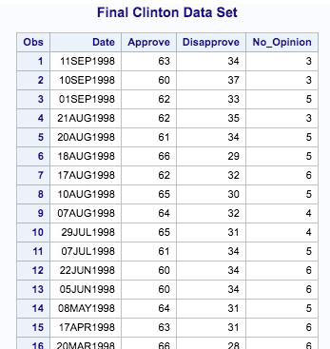

.

.

.

.

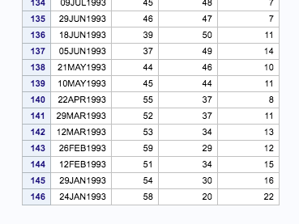

1. Using the SAS data set Blood, create two temporary SAS data sets called Subset_A and Subset_B. Include in both of these data sets a variable called Combined equal to 0.001 times WBC plus RBC. Subset_A should consist of observations from Blood where Gender is equal to Female and BloodType is equal to AB. Subset_B should consist of all observations from Blood where Gender is equal to **Female**, BloodType is equal to **AB**, and Combined is greater than or equal to **14**.

Code:

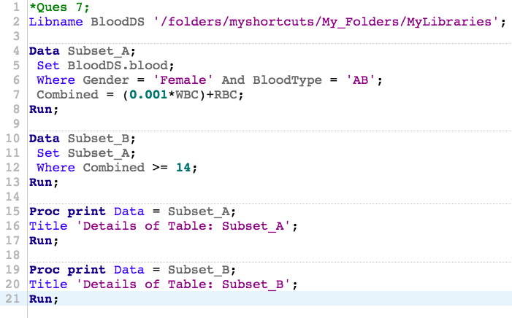

Log:

|  |
| --- |
| 1 OPTIONS NONOTES NOSTIMER NOSOURCE NOSYNTAXCHECK;  72  73 *Ques 7;  74 Libname BloodDS '/folders/myshortcuts/My_Folders/MyLibraries';  NOTE: Libref BLOODDS was successfully assigned as follows:  Engine: V9  Physical Name: /folders/myshortcuts/My_Folders/MyLibraries  75  76 Data Subset_A;  77 Set BloodDS.blood;  NOTE: Data file BLOODDS.BLOOD.DATA is in a format that is native to another host, or the file encoding does not match the session  encoding. Cross Environment Data Access will be used, which might require additional CPU resources and might reduce  performance.  78 Where Gender = 'Female' And BloodType = 'AB';  79 Combined = (0.001*WBC)+RBC;  80 Run;    NOTE: Missing values were generated as a result of performing an operation on missing values.  Each place is given by: (Number of times) at (Line):(Column).  2 at 79:19 1 at 79:24  NOTE: There were 20 observations read from the data set BLOODDS.BLOOD.  WHERE (Gender='Female') and (BloodType='AB');  NOTE: The data set WORK.SUBSET_A has 20 observations and 8 variables.  NOTE: DATA statement used (Total process time):  real time 0.01 seconds  cpu time 0.01 seconds      81  82 Data Subset_B;  83 Set Subset_A;  84 Where Combined >= 14;  85 Run;    NOTE: There were 4 observations read from the data set WORK.SUBSET_A.  WHERE Combined>=14;  NOTE: The data set WORK.SUBSET_B has 4 observations and 8 variables.  NOTE: DATA statement used (Total process time):  real time 0.01 seconds  cpu time 0.01 seconds      86  87 Proc print Data = Subset_A;  88 Title 'Details of Table: Subset_A';  89 Run;    NOTE: There were 20 observations read from the data set WORK.SUBSET_A.  NOTE: PROCEDURE PRINT used (Total process time):  real time 0.10 seconds  cpu time 0.10 seconds      90  91 Proc print Data = Subset_B;  92 Title 'Details of Table: Subset_B';  93 Run;    NOTE: There were 4 observations read from the data set WORK.SUBSET_B.  NOTE: PROCEDURE PRINT used (Total process time):  real time 0.04 seconds  cpu time 0.05 seconds      94  95 OPTIONS NONOTES NOSTIMER NOSOURCE NOSYNTAXCHECK;  108 |

Results:

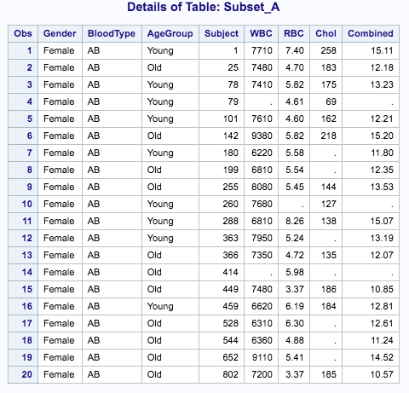

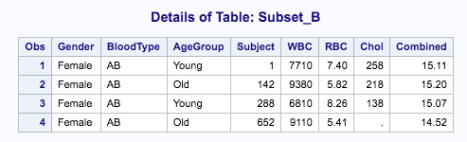

1. Using the SAS data set Blood, create two temporary SAS data sets by selecting all subjects with cholesterol levels (Chol) below 100. Place the male subjects in Lowmale and the female subjects in Lowfemale. Do this using a single DATA step.

Note: Values for Gender are Make and Female.

Careful, some of the cholesterol values are missing. Print the resulting data sets.

Code:

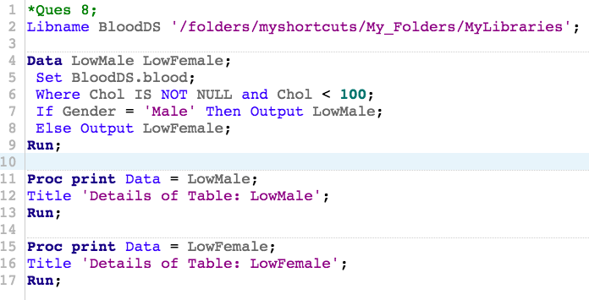

Log:

|  |
| --- |
| 1 OPTIONS NONOTES NOSTIMER NOSOURCE NOSYNTAXCHECK;  72  73 *Ques 8;  74 Libname BloodDS '/folders/myshortcuts/My_Folders/MyLibraries';  NOTE: Libref BLOODDS refers to the same physical library as _TEMP1.  NOTE: Libref BLOODDS was successfully assigned as follows:  Engine: V9  Physical Name: /folders/myshortcuts/My_Folders/MyLibraries  75  76 Data LowMale LowFemale;  77 Set BloodDS.blood;  NOTE: Data file BLOODDS.BLOOD.DATA is in a format that is native to another host, or the file encoding does not match the session  encoding. Cross Environment Data Access will be used, which might require additional CPU resources and might reduce  performance.  78 Where Chol IS NOT NULL and Chol < 100;  79 If Gender = 'Male' Then Output LowMale;  80 Else Output LowFemale;  81 Run;    NOTE: There were 12 observations read from the data set BLOODDS.BLOOD.  WHERE (Chol is not null) and (Chol<100);  NOTE: The data set WORK.LOWMALE has 8 observations and 7 variables.  NOTE: The data set WORK.LOWFEMALE has 4 observations and 7 variables.  NOTE: DATA statement used (Total process time):  real time 0.02 seconds  cpu time 0.01 seconds      82  83 Proc print Data = LowMale;  84 Title 'Details of Table: LowMale';  85 Run;    NOTE: There were 8 observations read from the data set WORK.LOWMALE.  NOTE: PROCEDURE PRINT used (Total process time):  real time 0.08 seconds  cpu time 0.08 seconds      86  87 Proc print Data = LowFemale;  88 Title 'Details of Table: LowFemale';  89 Run;    NOTE: There were 4 observations read from the data set WORK.LOWFEMALE.  NOTE: PROCEDURE PRINT used (Total process time):  real time 0.04 seconds  cpu time 0.04 seconds      90  91 OPTIONS NONOTES NOSTIMER NOSOURCE NOSYNTAXCHECK;  104 |

Results:

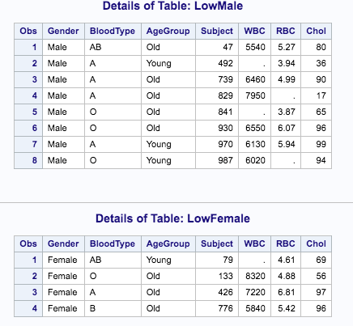

1. Using the SAS data sets Bicycles, create two temporary SAS data sets as follows: Mountain_USA consists of all observations from Bicycles where Country is **USA** and Model is **Mountain Bike**. Road_France consists of all observations from Bicycles where Country is **France** and Model is **Road Bike**. Print these two data sets.

Code:

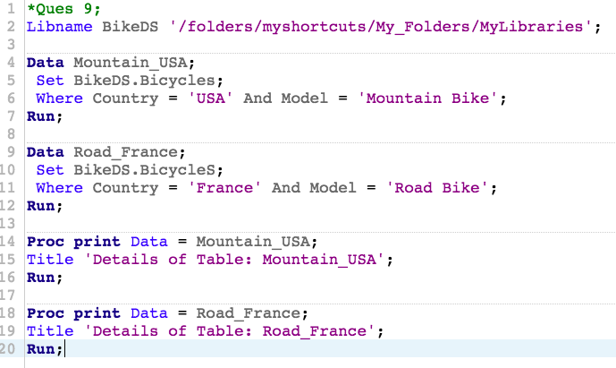

Log:

|  |
| --- |
| 1 OPTIONS NONOTES NOSTIMER NOSOURCE NOSYNTAXCHECK;  72  73 *Ques 9;  74 Libname BikeDS '/folders/myshortcuts/My_Folders/MyLibraries';  NOTE: Libref BIKEDS refers to the same physical library as _TEMP2.  NOTE: Libref BIKEDS was successfully assigned as follows:  Engine: V9  Physical Name: /folders/myshortcuts/My_Folders/MyLibraries  75  76 Data Mountain_USA;  77 Set BikeDS.Bicycles;  NOTE: Data file BIKEDS.BICYCLES.DATA is in a format that is native to another host, or the file encoding does not match the session  encoding. Cross Environment Data Access will be used, which might require additional CPU resources and might reduce  performance.  78 Where Country = 'USA' And Model = 'Mountain Bike';  79 Run;    NOTE: There were 2 observations read from the data set BIKEDS.BICYCLES.  WHERE (Country='USA') and (Model='Mountain Bike');  NOTE: The data set WORK.MOUNTAIN_USA has 2 observations and 6 variables.  NOTE: DATA statement used (Total process time):  real time 0.01 seconds  cpu time 0.01 seconds      80  81 Data Road_France;  82 Set BikeDS.BicycleS;  NOTE: Data file BIKEDS.BICYCLES.DATA is in a format that is native to another host, or the file encoding does not match the session  encoding. Cross Environment Data Access will be used, which might require additional CPU resources and might reduce  performance.  83 Where Country = 'France' And Model = 'Road Bike';  84 Run;    NOTE: There were 2 observations read from the data set BIKEDS.BICYCLES.  WHERE (Country='France') and (Model='Road Bike');  NOTE: The data set WORK.ROAD_FRANCE has 2 observations and 6 variables.  NOTE: DATA statement used (Total process time):  real time 0.01 seconds  cpu time 0.01 seconds      85  86 Proc print Data = Mountain_USA;  87 Title 'Details of Table: Mountain_USA';  88 Run;    NOTE: There were 2 observations read from the data set WORK.MOUNTAIN_USA.  NOTE: PROCEDURE PRINT used (Total process time):  real time 0.08 seconds  cpu time 0.06 seconds      89  90 Proc print Data = Road_France;  91 Title 'Details of Table: Road_France';  92 Run;    NOTE: There were 2 observations read from the data set WORK.ROAD_FRANCE.  NOTE: PROCEDURE PRINT used (Total process time):  real time 0.03 seconds  cpu time 0.04 seconds      93  94 OPTIONS NONOTES NOSTIMER NOSOURCE NOSYNTAXCHECK;  107 |

Results:

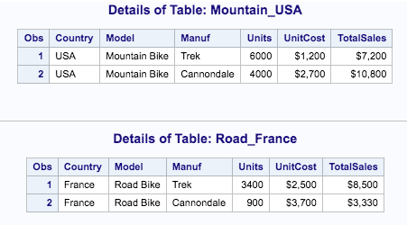

1. Print out the observations in the two data sets Inventory and NewProducts. Next, create a new temporary SAS data set (Updated) containing all the observations in Inventory followed by all the observations in NewProducts. Sort the resulting data set by model and print out the observations.

Code:

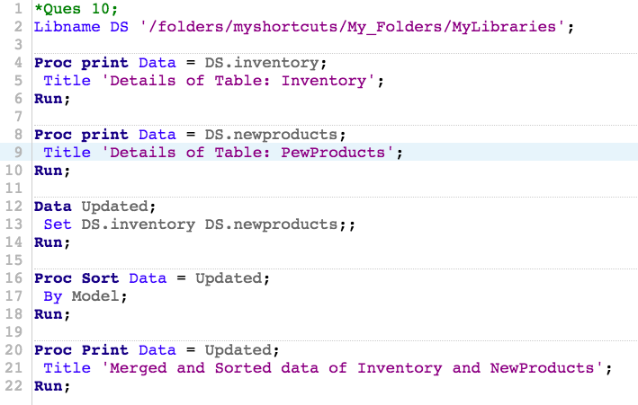

Log:

|  |
| --- |
| 1 OPTIONS NONOTES NOSTIMER NOSOURCE NOSYNTAXCHECK;  72  73 *Ques 10;  74 Libname DS '/folders/myshortcuts/My_Folders/MyLibraries';  NOTE: Libref DS refers to the same physical library as _TEMP4.  NOTE: Libref DS was successfully assigned as follows:  Engine: V9  Physical Name: /folders/myshortcuts/My_Folders/MyLibraries  75  76 Proc print Data = DS.inventory;  NOTE: Data file DS.INVENTORY.DATA is in a format that is native to another host, or the file encoding does not match the session  encoding. Cross Environment Data Access will be used, which might require additional CPU resources and might reduce  performance.  77 Title 'Details of Table: Inventory';  78 Run;    NOTE: There were 6 observations read from the data set DS.INVENTORY.  NOTE: PROCEDURE PRINT used (Total process time):  real time 0.05 seconds  cpu time 0.06 seconds      79  80 Proc print Data = DS.newproducts;  NOTE: Data file DS.NEWPRODUCTS.DATA is in a format that is native to another host, or the file encoding does not match the session  encoding. Cross Environment Data Access will be used, which might require additional CPU resources and might reduce  performance.  81 Title 'Details of Table: PewProducts';  82 Run;    NOTE: There were 2 observations read from the data set DS.NEWPRODUCTS.  NOTE: PROCEDURE PRINT used (Total process time):  real time 0.04 seconds  cpu time 0.03 seconds      83  84 Data Updated;  85 Set DS.inventory DS.newproducts;;  NOTE: Data file DS.INVENTORY.DATA is in a format that is native to another host, or the file encoding does not match the session  encoding. Cross Environment Data Access will be used, which might require additional CPU resources and might reduce  performance.  NOTE: Data file DS.NEWPRODUCTS.DATA is in a format that is native to another host, or the file encoding does not match the session  encoding. Cross Environment Data Access will be used, which might require additional CPU resources and might reduce  performance.  86 Run;    NOTE: There were 6 observations read from the data set DS.INVENTORY.  NOTE: There were 2 observations read from the data set DS.NEWPRODUCTS.  NOTE: The data set WORK.UPDATED has 8 observations and 2 variables.  NOTE: DATA statement used (Total process time):  real time 0.03 seconds  cpu time 0.01 seconds      87  88 Proc Sort Data = Updated;  89 By Model;  90 Run;    NOTE: There were 8 observations read from the data set WORK.UPDATED.  NOTE: The data set WORK.UPDATED has 8 observations and 2 variables.  NOTE: PROCEDURE SORT used (Total process time):  real time 0.00 seconds  cpu time 0.00 seconds      91  92 Proc Print Data = Updated;  93 Title 'Merged and Sorted data of Inventory and NewProducts';  94 Run;    NOTE: There were 8 observations read from the data set WORK.UPDATED.  NOTE: PROCEDURE PRINT used (Total process time):  real time 0.04 seconds  cpu time 0.04 seconds      95  96 OPTIONS NONOTES NOSTIMER NOSOURCE NOSYNTAXCHECK;  109 |

Results:

